# **Testing Instructions**

## 1. Unit Tests

- Validate Domain match (same domain in Lead.Email and Account.Website)  
- Validate Fuzzy match (close company names with high similarity)  
- Validate Combined match (both criteria satisfied)  
- Validate no match scenarios. Expectation – Lead gets created as is without Account mapping.

Refer to below screenshot for test lead record entry for corresponding accounts.

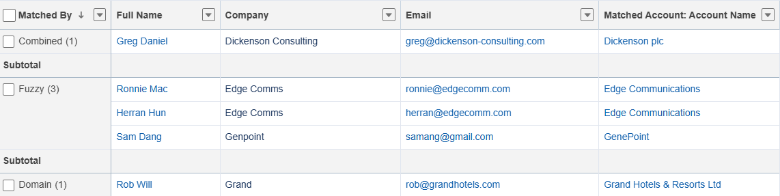

## 2. Edge Case Testing

|  |  |
| --- | --- |
| **Scenario** | **Expected Outcome** |
| Missing email or website fields | Lead gets created as is without Account mapping |
| Invalid formats or empty strings | Handle the invalid formats and create lead with/without Account map |
| Whitespace and casing differences | Handle the scenario |

## 3. Code Coverage

|  |  |  |
| --- | --- | --- |
| **Component** | **Test Class** | **Coverage** |
| LeadAccountMatcher | LeadAccountMatcherTest | 100% |
| StringMatchUtils | StringMatchUtilsTest | 100% |
| LeadTrigger | LeadTriggerTest | 100% |
| LeadTriggerHandler | LeadTriggerTest | 100% |

Expected Coverage: ≥ 95% with assertions validating outcomes.